6 Zones Mixer Amplifier with Mp3
TI-1206S/TI-2406S/TI-3506S/TI-5006S

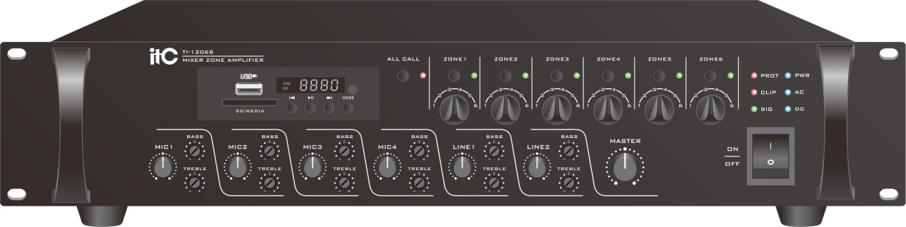

Features TI-1206S/TI-2406S/TI-3506S/TI-5006S
* 4 Channel Microphone and 2 line input, treble and bass can be controlled separately .
* 6 Channel Partition output, and partition volume independent control.
* Built in bell. Bell tone optional: 4 tones and 2 tones (built-in), alarm generator.
* Mp3 decoding module supports usb/sd/bluetooth/fm radio playback function. With
the MP3 remote control, support power off memory function, MIC recording function.
* When the alarm generator starts, background music will be closed and6 partition
output will automatically open to maximum output volume.
* Built in 24V DC power input.
* Mic1- 4 built-in 48V phantom power supply, and switch can be independently
controlled.
* T-216 partition control microphone can remotely control partition output, and it can
be cascaded up to 6 units.
* Audio input with independent control on tone control and total volume control.
* A variety of indicator lights (signal, the top of the roof, to protect the LED indicator)
* Using fan forcible cooling structure, allowing the machine to work for a long time.
* There are 5 priority functions:
The first level EMC priority: when input the EMC alarm signal, all the sound source will
be turn off, and the 6 Channel partition output will automatically open.
Second level: tel/rem mic override mic1-4, line1-2 and bell tone.
Third level: built-in alarm generator override bell sound, mic1-4, line1-2, 6 partition
output will automatically open.
Fourth level: built-in bell tone override mic1-4, line1-2.
Fifth level: built-in mic1 override mic2-4, line1-2.
* Constant voltage output: 70V, 100V, rated resistance output: 4-16 Ω.

Specifications
Model |  | TI-1206S |  | TI-2406S |  | TI-3506S |  | TI-5006S
Amplifier Section  (Load 100V Output) | Rated Output Power (THD 1%) | 120W(RMS) |  | 240W(RMS) |  | 350W(RMS) |  | 500W(RMS)
 | Speaker Zone 1~5 Output | 25W MAX |  | 50W MAX |  | 70W MAX |  | 85W MAX
Mic Input Section  (Mic 1~4 In@1KHz) | Input Sensitivity/Impedance | 5mV 600Ω/350mV 10KΩ BAL
 | S/N Ratio | Better than 75dB
 | Frequency Response (±3dB) | 80Hz~16KHz
 | Tone Control (Bass:100Hz, Treble:10KHz) | ±10dB
 | Phantom Power | + 48V
Line Input Section  (Mic 1~2 In@1KHz) | Input Sensitivity/Impedance | 350mV/47KΩ
 | S/N | Better than 80dB
 | Frequency Response (±3dB) | 80Hz~16KHz
 | Tone Control (Bass: 100Hz,Treble:10KHz) | ±10dB
Tel Audio Input | Input Sensitivity/Impedance | 0.775V/10KΩ
 | S/N | Better than 75dB
 | Frequency Response (±3dB) | 50Hz~16KHz
EMC Audio Input | Input Sensitivity/Impedance | 0.775V/10KΩ
 | S/N | Better than 75dB
 | Frequency Response (±3dB) | 80Hz~16KHz
Pre Amp Out(Mic 1~4, Line 1~2, Tel In, Remote In) |  | 1V/600Ω
Remote MIC Sensitivity/Impedance |  | 775mV/10KΩ
THD |  | Less than 0.1% at 1KHz, 1/3 rated power
Power Supply |  | ~110-230V 50/60Hz & DC 24V
Power Consumption |  | 180W | 320W |  | 500W |  | 750W
Weight |  | 6.5Kg | 7.1Kg |  | 7.8Kg |  | 8.9Kg
Dimensions |  | 484x310x88 mm

Rear Panel TI-1206S/TI-2406S/TI-3506S/TI-5006S
